Project 6: Third-Party and SD-WAN Design Authority (SD-WAN and Zscaler ZPA)

Two outside products often connect to AWS. This project makes sure each one is plugged in the same safe way every time.
- SD-WAN: software that links branch offices to each other and to AWS over several internet or private links, and picks the best one.
- Zscaler ZPA: lets users reach private apps without a traditional VPN. A small connector inside AWS makes an outbound connection to Zscaler. Nothing opens inbound.
- Your job: be the design authority. Write the integration patterns and the onboarding rules for AWS workloads.

Network diagram
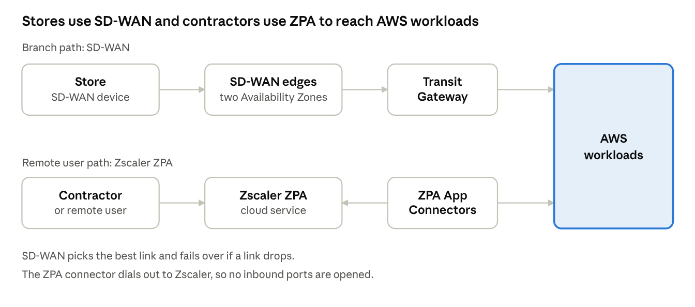
SD-WAN and ZPA paths into AWS
Branches reach AWS through SD-WAN edges and the Transit Gateway. Remote users reach one app through Zscaler and the ZPA connectors.

Integration patterns and onboarding rules
Area | Standard pattern
SD-WAN in AWS | Run SD-WAN virtual edges in a dedicated VPC and connect them to the Transit Gateway.
Redundancy | At least two SD-WAN edges in different Availability Zones.
ZPA connectors | Run App Connectors in private subnets. At least two per application area, in different Availability Zones.
Access | Connectors need only outbound access. No inbound ports are opened.
Onboarding | A workload follows a checklist: approved subnet, security group, connector placement, and a named owner.

Production use case
Example scenario: a retail chain has 300 stores. Each store till must reach the inventory system in AWS. Contractors also need to open an internal admin web app.
- Each store runs an SD-WAN device that links to the SD-WAN edges in AWS and then to the Transit Gateway.
- If a store's broadband fails, SD-WAN switches to its backup link, so tills keep working.
- Contractors sign in through ZPA and reach only the admin app, not the whole network.
- The ZPA connectors sit in private subnets and make outbound-only connections.
Result: stores stay online, and outside users get access to one app instead of the whole network.

Interview questions and answers
Practice questions at the depth that senior cloud-network interviews at companies like AWS, Google and Meta expect. They are not official lists.
Q1. How do you connect an SD-WAN to AWS?
Run the vendor's virtual edges in a dedicated VPC and attach them to the Transit Gateway. Options include Transit Gateway Connect (GRE tunnels with BGP) or VPN attachments. Use at least two edges in different AZs and let BGP exchange routes.
Q2. How is Zscaler ZPA different from a traditional VPN?
A VPN puts the user on the network. ZPA connects a user to one named application only. The App Connector dials out to Zscaler, so no inbound ports are opened and the network is not exposed.
Q3. Where do you place ZPA App Connectors and how many?
In private subnets close to the apps they serve, at least two per application area in different AZs. Group them by app segment so one failure or one over-broad rule does not affect everything.
Q4. A store loses its main link. What should happen?
The SD-WAN device detects the loss and moves traffic to the backup link, such as a second broadband line or cellular. Tills stay online. Test this on a pilot store before rolling out.
Q5. How do you onboard a new workload to ZPA safely?
Use a checklist: approved subnet, security group, connector placement, named owner, and an access policy for only the users who need the app. The change goes through the pipeline and is logged.
Q6. How do you judge a third-party networking product for your design?
Check how it fits AWS patterns, high-availability design, routing support, monitoring, cost model, and exit plan. Run a proof of concept with a failure test before choosing.

